MAGI BIBLE
Magistrate Product, UI, Voice, Architecture & Implementation Reference
A single source of truth for implementation agents, design work, testing, and release decisions
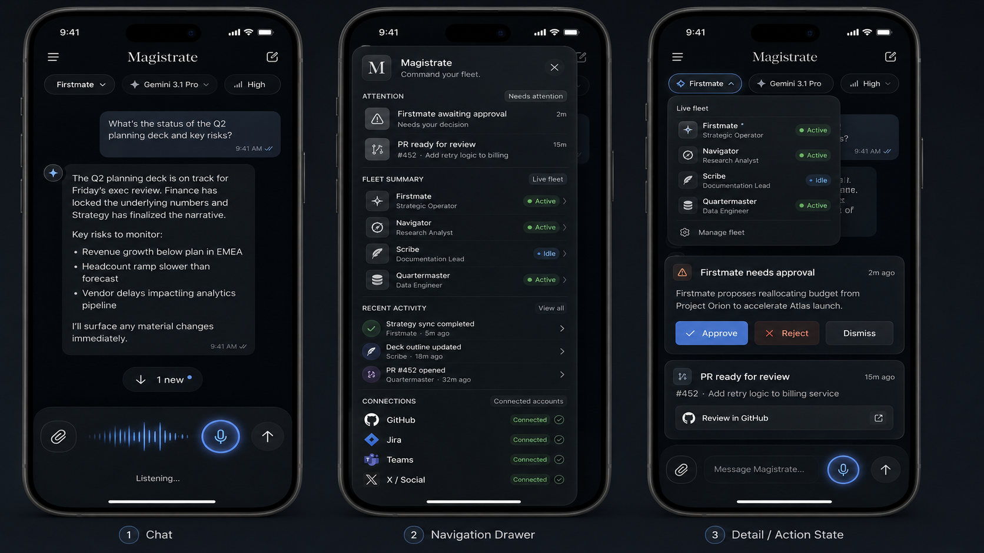
Current target interaction direction: chat-centered AI assistant with drawer, fleet, attention, connections, and compact action states.
STATUS OF THIS DOCUMENT
This Bible records the latest product direction plus known infrastructure facts. It deliberately separates confirmed implementation from required/target behavior. When it conflicts with an older mock or prompt, the most recent explicit product direction in this document should win.

Table of contents
1. Executive product definition
2. Source-of-truth rules and current status
3. Product principles and user experience
4. Visual identity and design language
5. Information architecture and navigation
6. Chat experience
7. Attention system
8. Fleet summary and agent conversations
9. Recent activity
10. Connections, accounts, OAuth and profile
11. GitHub integration
12. Jira and Microsoft Teams
13. Voice: conversational mode, personality and audio
14. Siri, App Intents and hardware entry
15. Backgrounds and appearance
16. Native iPhone packaging and distribution
17. Backend, control plane and private runner architecture
18. Firstmate + Herdr integration contract
19. Harness/model selection and dispatch routing
20. Realtime events, unread state and notifications
21. Security and authorization boundaries
22. Data model and API contract recommendations
23. Deployment architecture
24. MVP V1 definition of done
25. Testing and acceptance matrix
26. Implementation-agent operating rules
27. Current dev/server environment snapshot
28. Release and GitHub delivery procedure
29. Future roadmap
30. Open questions / verify-in-repo checklist

1. Executive product definition
Magistrate is a native, mobile-first command cockpit for Firstmate. Its surface should feel as simple and familiar as a modern AI chat application, while Firstmate, Herdr, GitHub and future connected work systems operate underneath it.
CORE PRODUCT SENTENCE
I am talking to one intelligent system, while an entire engineering organization works underneath it.

The product is not intended to recreate Herdr as a terminal UI. Herdr is structural inspiration for live agents, spaces and status; Magistrate translates that power into a calm consumer-grade conversation interface.
User
↓
Magistrate (chat / voice / attention / fleet / connections)
↓
Firstmate (captain / orchestration / delegation / supervision)
↓
Herdr + Treehouse + harnesses
↓
Claude / Codex / Pi / agy-Gemini / future local workers

The long-term vision is location-independent productivity: the user should be able to work from anywhere with only an iPhone and voice, then later add AR glasses, headset audio, camera input, subvocal input or other modalities without changing the Firstmate command model.

2. Source-of-truth rules and current status
Because Magistrate has evolved quickly, this document uses an explicit precedence rule to prevent old concepts from resurfacing as accidental requirements.
- Newest explicit product requirement or acceptance criterion wins.
- Actual behavior verified in the repository/device outranks assumptions in planning prompts.
- Older concept art is inspiration unless the later product direction preserved it explicitly.
- No implementation agent may invent a capability, provider, status, metric, OAuth success, model or live event to make the UI look complete.
Area | Current known state | Treatment in this Bible
Core agent stack | Firstmate + Herdr are actively used on melkezic; Pi/Codex/Claude are available or being repaired/updated. | Confirmed infrastructure.
Primary captain | Pi with GPT-5.6 Luna has been used as the Firstmate brain; Codex and Claude are alternatives. | Confirmed workflow, not a permanent product lock-in.
Native iOS app | Expo Go is not sufficient for the current project; the app must become a real installable iOS build. | Required MVP behavior.
Chat-centered redesign | Latest desired UI is a traditional AI-chat surface with a mobile drawer, live fleet, attention, activity and connections. | Current visual/interaction target.
Voice | Existing behavior felt like a screen reader / push-to-talk. This is explicitly rejected. | Must become persistent conversational voice before MVP V1 is complete.
GitHub | GitHub authentication exists on melkezic; PR brief should use real data. | MVP bridge now; per-user OAuth later.
Jira / Teams | Desired connected accounts and live work notifications. | Required integration direction; actual implementation must be verified.
Backgrounds | Existing atmospheric/glass direction; new built-ins + custom upload are required. | Required before MVP V1 sign-off.
Local Qwen worker | qwen3:8b tested poorly as an autonomous worker. | Do not route general work to it.
Antigravity / Gemini | Desired as a Firstmate harness/captain path once upstream agy adapter is integrated. | Planned/experimental until verified.

3. Product principles and user experience
- Chat first: conversation is the default workspace, not a dashboard of metrics.
- Human attention first: surface only what requires judgment, approval, review or awareness.
- Fleet power without fleet clutter: agents are visible and reachable, but tool noise stays hidden.
- Real data only: empty/error/loading states are better than fake content.
- Voice first, not voice only: typed chat, Siri, Action Button and future wearables all enter the same conversation/state system.
- Model agnostic: Magistrate does not become married to Claude, GPT, Gemini or any one voice provider.
- Firstmate remains the orchestrator: Magistrate is the interface/control plane, not a competing agent framework.
- Native mobile stability: no accidental viewport zoom, no keyboard-induced scaling, no horizontal overflow, no squeezed desktop UI.
- Consequential actions require explicit confirmation; speech recognition errors must not deploy, merge or delete things accidentally.
- Calm surface, deep system: high activity underneath should not make the UI feel noisy.

4. Visual identity and design language
Magistrate has two established visual ideas: a minimal atmospheric glass/air design and the newer chat-centered AI assistant layout. The newest chat-centered layout is the primary interaction model; the glass/air aesthetic remains the visual language.
Element | Direction
Wordmark | Classical, sharp, high-contrast editorial serif.
UI typography | Clean sans-serif for operational content.
Color systems | Support both dark and light environments. Light base: neutral white/gray. Dark base: black/charcoal with restrained cool accents.
Icons | Minimal monochrome line icons. Use color mainly for state (active/idle/error/approval) and sparingly.
Surfaces | Subtle glassmorphism, soft depth, minimal borders, generous negative space.
Background | Atmospheric/time-aware background behind readable glass layers.
Voice mark | Organic triangle/spiral remains a brand motif, but the latest voice UX stays anchored in Firstmate Chat rather than forcing a separate full-screen voice-only mode.
Motion | Subtle waveform, mic glow, connection/status transitions; avoid flashy decorative motion.

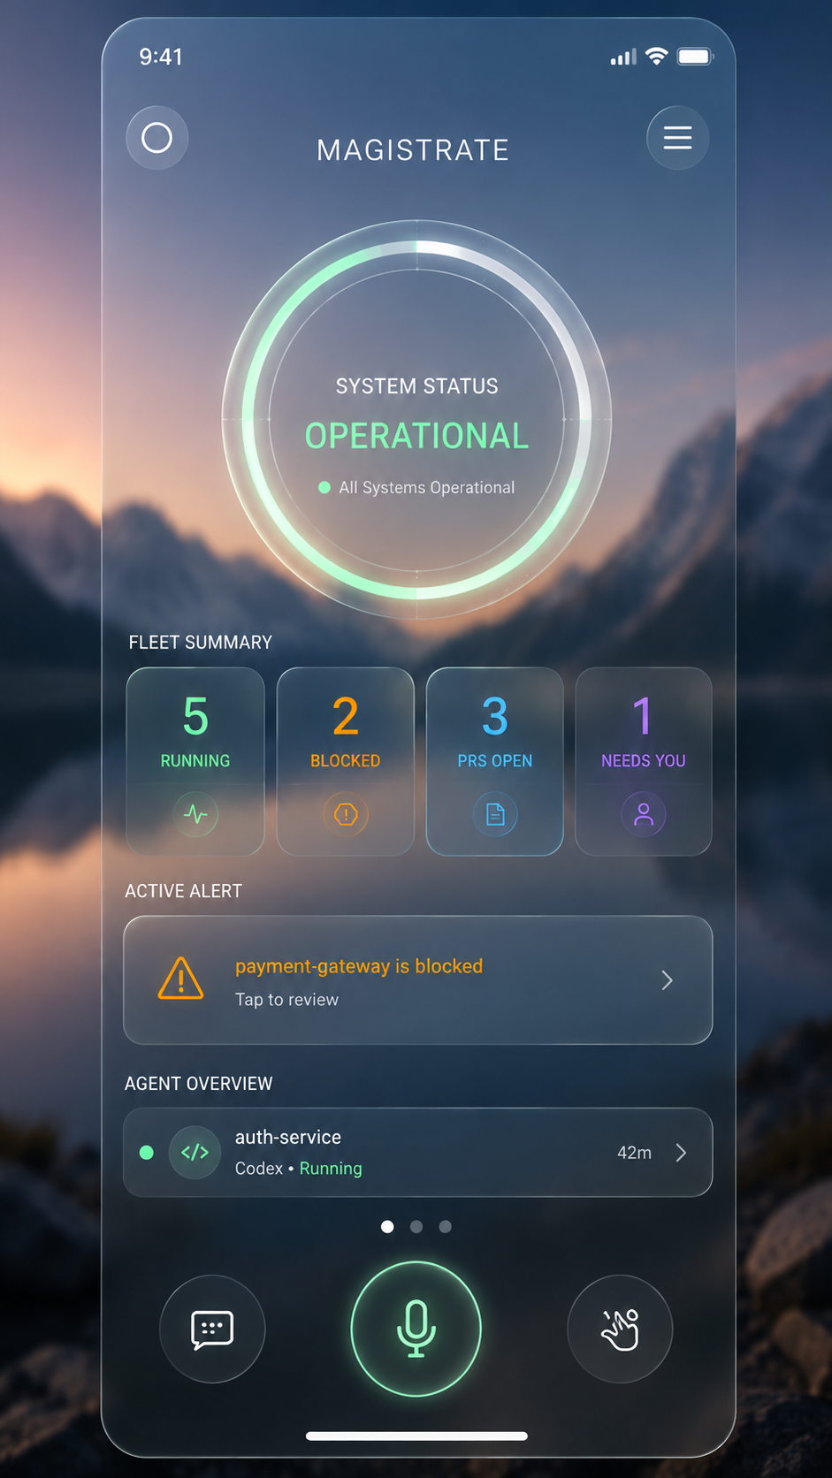
Earlier visual source: glass/air dashboard concept. Preserve the atmospheric restraint, not the metric-heavy dashboard structure.

5. Information architecture and navigation
The main shell is a modern AI-chat layout with a mobile drawer. On iPhone the drawer overlays or slides over the chat rather than permanently consuming width. Tablet/desktop may show a persistent sidebar when space permits.
Navigation section | Purpose | Core interaction
Attention | Everything that needs human judgment or review. | Tap item → compact brief/action sheet.
Fleet Summary | Live Firstmate + crew list and statuses. | Tap section → expand/collapse agent list; tap agent → agent chat.
Recent Activity | Meaningful outcomes/events, not raw tool logs. | Tap event → relevant agent, PR, task or conversation.
Connections | GitHub, Jira, Teams and future providers. | Real OAuth/account management and capability health.
Settings | Appearance, voice/personality, notifications, developer diagnostics. | Native settings experience.

Normal launch should land in Firstmate chat. Siri/Action Button voice launch should land directly in Firstmate chat with the mic/listening session already active. Notifications deep-link to the relevant action/agent/PR/Jira/Teams object rather than routing everything through the home screen.

6. Chat experience
Chat is the central Magistrate experience. It should look and behave like a polished modern AI assistant rather than a terminal transcript.
- Display only user messages, agent messages, attachments, decision/action cards, and minimal state.
- Hide normal tool calls, shell commands, patches, code-edit traces, token logs and internal reasoning from the main chat.
- Provide an optional Developer → Diagnostics view for raw operational debugging without polluting chat.
- Composer controls: attachment, text input, microphone, send.
- Conversation header: agent name, live status, current task/project when known, and compact harness/model/strength selector.
- Chats support long history with virtualization/pagination: recent messages first, older history on demand.
- If the user scrolls away from the bottom, do not auto-jump. When new content arrives show a floating down pill such as “↓ New message” or “↓ 3 new”.
- Tapping the pill jumps to the most recent message. Track unread state per conversation.
- Agent replies should arrive in real time where transport supports it; reconnection must be graceful.
- Empty, loading, reconnecting and error states must be explicit and never replaced by fake messages.
[ + ] Ask Firstmate anything... [ mic ] [ ↑ ]

7. Attention system
Attention is the canonical queue for human intervention across Firstmate and connected services. It should answer the question: “What needs me?”
Source/type | Brief content | Primary actions
Firstmate approval / blocked agent | Source, short reason, relevant context, timestamp, risk/impact. | Approve / Reject / Dismiss when semantically safe.
GitHub PR | Repo, PR number, title, author, branch, CI, review status, short summary. | Review in GitHub / Dismiss.
Future Jira | Issue key, project, status, priority, assignee, why it needs attention. | Open issue; later scoped write actions.
Future Teams | Mention/chat/channel, sender, timestamp, concise context. | Open Teams/deep link; later scoped actions.

Dismiss must never silently mean approve/reject. High-impact operations need an explicit confirmation boundary. Counts/badges must be based on real attention state.
NORMALIZED MODEL
AttentionItem should normalize source, sourceId, type, priority, title, summary, timestamp, requiresAction, actions, deepLink and resolved/read state so new providers plug into one experience.

8. Fleet summary and agent conversations
Fleet Summary gives a live, compact view of Firstmate and every crew agent Firstmate spawns. The top-level view may show real counts such as Active/Idle only when those values are trustworthy.
Status | Meaning
Active | Agent is currently executing or producing work.
Idle | Agent exists but is not currently doing work.
Blocked | Agent cannot proceed without a dependency/decision.
Waiting | Agent is deliberately waiting for an event/result.
Disconnected | Agent/session is no longer connected.
Unknown | State cannot be determined reliably; do not guess.

Tapping Fleet Summary expands individual agents. Tapping an agent opens that agent’s chat and automatically loads its latest available messages. The app should use structured/durable conversation state where possible rather than reconstructing fake chats from ANSI terminal output.
- Each agent chat supports scrollback, unread state and jump-to-latest.
- If sending directly to a crew agent is supported by the underlying contract, the composer targets that agent. Otherwise the UI must not pretend direct messaging is available.
- Surface current task/project in the header when known.
- Do not expose raw Herdr pane IDs in normal UX unless needed in Diagnostics.

9. Recent activity
Recent Activity is a concise chronological stream of meaningful outcomes, not every shell command or token event.
11:42 fm-auth opened PR #142
11:36 Firstmate dispatched fm-api
11:31 fm-ui completed tests
11:22 PR #141 merged

Events should deep-link to the relevant agent, PR, task, conversation or external service. Activity storage should be normalized enough to support future push notifications and searchable history.

10. Connections, accounts, OAuth and profile
The Account/Connections experience must stop being a toy. It is a real identity and capability layer for mobile/voice access to external services.

10.1 Profile
- Choose or capture a profile picture from the iPhone.
- Persist the uploaded image against the Magistrate account using durable storage, not a temporary picker URI.
- Display the profile image wherever avatars are used.
- Allow replace/remove.
- Handle iOS permissions gracefully.

10.2 Connected account architecture
Magistrate user
↓
ConnectedAccount
↓
OAuth authorization
↓
server-side credential storage
↓
ProviderAdapter / capabilities
↓
Magistrate + Firstmate

- Credentials remain server-side; never log access/refresh tokens or send them through Firstmate prompts.
- Request minimum scopes necessary for implemented capabilities.
- Support connect, callback, refresh, disconnect/revoke, expiry, failed auth, reconnect and capability detection.
- If a provider cannot support a requested feed/posting capability, expose it as unavailable rather than faking it.
- Account UI shows provider, account identity, connection health, granted capabilities, reconnect and disconnect.

11. GitHub integration
GitHub is a first-class integration because Magistrate is a control surface for software work. For the current personal MVP, the PR Brief should connect to the real GitHub authentication already available on melkezic. Long term, each Magistrate user connects their own GitHub account through OAuth.
PR field | Requirement
Repository / PR number | Real values from GitHub.
Title / author / branch | Real metadata.
Status / review status | Reflect provider state.
CI/checks | Surface concise pass/fail/pending summary.
Mergeability | Show only when available/reliable.
Summary / attention | Short, user-centered brief.
Link | Actual GitHub URL; Review opens GitHub app when available, browser otherwise.

Use real GitHub tooling/API already available to Firstmate/gh-axi/gh. Never scrape GitHub HTML, hardcode repo names, or embed user credentials in the app.

12. Jira and Microsoft Teams
Jira and Teams are intended to make Magistrate useful for live work awareness, including EVERSANA work, while respecting enterprise tenant policies and confidentiality.

12.1 Jira
- Use supported Atlassian OAuth for Jira Cloud.
- Initial read capabilities: issues assigned to me, issues needing attention, recent updates, status, priority, project, due date, comments/activity and deep links.
- Keep read and write permissions separate. Add write scopes only when a real write feature is implemented.
- Normalize important Jira changes into AttentionItem/event records and native notifications.

12.2 Microsoft Teams
- Use Microsoft identity/OAuth and Microsoft Graph where permitted; never scrape Teams.
- Initial capabilities: relevant chats/messages, mentions, channel activity, meeting-related activity and deep links where API/tenant policy permits.
- Enterprise admin consent may be required. Detect and communicate that cleanly; do not bypass organization controls.
- Separate read/write scopes and avoid broad write permission just to support awareness/notifications.
WORK-DATA BOUNDARY
Do not mix employer credentials or confidential work content with personal provider credentials. Before sending enterprise content to external models, enforce an explicit policy boundary and whatever employer rules apply.

13. Voice: conversational mode, personality and audio
Voice is the final major MVP V1 experience gate. The current push-to-talk / screen-reader-like behavior is not acceptable. Magistrate should feel like a persistent phone call with a sophisticated assistant.
START SESSION ONCE
↓
LISTENING → TRANSCRIBING → THINKING → SPEAKING
↑ ↓
└──────── auto return / barge-in ──────┘

- One tap, Siri invocation or Action Button starts a persistent voice session.
- Do not require pressing the mic again for every turn.
- Use voice activity detection / turn detection so the system knows when the user starts/stops speaking.
- Show live partial transcription in the Firstmate composer and preserve the normal text history.
- Stream Firstmate response text and begin TTS on sentence/semantic chunks rather than waiting for a long complete response.
- Support barge-in: when the user speaks during TTS, stop TTS and listen immediately.
- Prevent self-transcription by coordinating iOS audio session, echo cancellation and STT/TTS state.
- Respect Bluetooth/AirPods/wired route; do not hardcode speaker output.
- Allow voice input on with voice output off (quiet/text-only response mode).
- Voice remains an interface around Firstmate. Do not replace Firstmate with a second authoritative voice LLM.

13.1 Voice provider architecture
VoiceSession
├── SpeechToTextProvider
├── FirstmateConversationProvider
└── TextToSpeechProvider

A recommended implementation path discussed is ElevenLabs Speech Engine / realtime React Native tooling for STT/VAD/turn-taking/TTS around the existing custom Firstmate agent. Apple Speech/native TTS or other providers remain valid behind the same interfaces. The key requirement is provider independence.

13.2 Personality controls
The target feel is an original/licensed, composed cinematic executive assistant: British-leaning if desired, competent, concise, understated, slightly warm, occasional dry wit. Do not clone the exact JARVIS/Paul Bettany voice.
Setting | Examples
Personality preset | Magistrate / Professional / Concise / Friendly / Custom.
Voice | Only actual supported/licensed voices.
Verbosity | Concise ↔ detailed.
Warmth / formality | User-adjustable.
Humor | Minimal ↔ more frequent.
Auto-speak | On/off.
Continuous conversation | On/off.
Speech speed | Normal + supported range.

Spoken output may summarize verbose engineering details into natural language while the complete Firstmate response remains visible in text.

14. Siri, App Intents and hardware entry
Magistrate cannot replace Apple’s system-wide “Hey Siri” wake word or hijack the Siri side button. The supported native solution is App Intents/App Shortcuts plus optional Action Button assignment.
Entry | Expected behavior
“Siri, use Magistrate mic” / similar App Shortcut | Launch Magistrate directly into Firstmate Chat with continuous voice session already listening.
Parameterized Siri intent when supported | Spoken text can become a Magistrate/Firstmate command without extra navigation.
Action Button shortcut | Same direct voice route; one press/hold starts listening.
Normal icon launch | Normal chat-centered Firstmate screen, not forced voice mode.
Push notification | Deep-link directly to relevant attention/PR/Jira/Teams/agent detail.

Native deep-link targets should include conceptual routes such as magistrate://voice, /firstmate, /attention, /github/pr/{id}, /jira/{key}, /teams/{target}. Use universal links where beneficial.

15. Backgrounds and appearance
Appearance customization is part of MVP V1. Preserve the minimal atmospheric glass design while making backgrounds user-selectable and uploadable.
Mode | Behavior
Automatic | Select appropriate background from time of day and weather when available.
Built-in | Curated original/licensed themes such as clear, cloudy, rain, storm, sunset, night, minimal dark.
Custom | Choose image from iPhone photo library; persist it durably; replace/remove later.
Readability layer | Adaptive dim/blur/gradient between image and glass UI so text remains usable.

Built-in assets must be generated/original/licensed and optimized for iPhone package size/performance. Settings path: Settings → Appearance → Background.

16. Native iPhone packaging and distribution
Magistrate must be a real iPhone app, not a browser destination and not dependent on Expo Go. Expo Go is currently insufficient for the project’s required native capabilities/version.
Stage | Preferred path
Personal device development | EAS native development/preview build installed on registered iPhone.
Friends / MVP beta | TestFlight external/internal distribution.
Public release | App Store Connect submission after beta validation.

- Configure stable bundle identifier, EAS project/eas.json, microphone/photo/notification permissions, native plugins and Apple capabilities.
- Native features include App Intents/Siri, push notifications, deep links and audio session behavior.
- Test on physical iPhone; simulator-only success is insufficient for mic, Siri, audio routes and device lifecycle.

17. Backend, control plane and private runner architecture
The App Store distributes only the iPhone client. The backend/control plane must run separately. The personal dev server must not become the general public server for friends or future users.
Native iPhone app
↓ HTTPS / WSS
Hosted Magistrate control plane
├── Auth / profile / connections
├── Attention / activity / notifications
├── Postgres / Redis
└── secure job/event gateway
↑ outbound/private connection
melkezic runner
↓
Herdr
↓
Firstmate

For the current Django/ASGI/Channels direction, Render was preferred over Vercel for the MVP because a persistent Django Channels/WebSocket service maps naturally to the existing architecture. Vercel can host Django and now supports WebSockets, but the serverless/beta model is less natural for this backend. This is a deployment recommendation, not a permanent vendor lock.
melkezic should remain a private Firstmate runner. Do not expose raw SSH, Herdr sockets, Claude sessions, filesystem or GitHub credentials to the public internet. Prefer Tailscale/private connectivity and/or an authenticated outbound runner connection.

18. Firstmate + Herdr integration contract
Magistrate should wrap Firstmate; it should not fork/reimplement Firstmate unless a genuine missing contract forces it. Firstmate remains the engineering manager/orchestrator.
Magistrate
↓
FirstmateAdapter / Runner API
↓
Herdr native CLI/socket + Firstmate durable state/helpers
↓
Firstmate / crew

- Use structured Firstmate/Herdr APIs/helpers/state rather than parsing the visible TUI or ANSI output.
- Herdr provides persistent sessions, panes and agent control. Treehouse provides isolated worktrees.
- Useful Firstmate concepts include crew state, decision holds, watcher/supervision state, backlog/tasks and PR outcomes.
- Agent command ingress should use Herdr agent prompt/socket semantics, not brittle terminal send-key scraping where a native control path exists.
- Magistrate chat should not expose tool traces from these systems in the normal surface.

18.1 Suggested runner contract
FirstmateRunner
├── sendCommand()
├── getStatus()
├── getAgents()
├── getAttentionItems()
├── getPullRequests()
├── interruptAgent()
├── resumeAgent()
└── getEvents()

19. Harness/model selection and dispatch routing
Magistrate should expose current harness/model/strength as a compact selector, but Firstmate’s built-in crew-dispatch system remains the primary routing mechanism for spawned work. Magistrate does not need to invent a second AI router.
Concept | Current direction
Captain | Pi + GPT-5.6 Luna has been used successfully as the Firstmate brain. Claude and Codex remain valid alternatives.
Worker dispatch | Firstmate reads config/crew-dispatch.json natural-language rules and chooses harness/model/effort.
Local Qwen | qwen3:8b successfully ran on RTX 2080 Super but performed poorly as autonomous Firstmate worker; do not default-route general tasks to it.
Gemini | Desired via Google Antigravity/agy harness, ideally Gemini 3.1 Pro High, once adapter is integrated and supervision verified.
UI selector | Show only actually detected/supported harnesses/models/effort controls; distinguish session override from future-spawn defaults.

A future cost-efficient router can use strong/cheap providers for scouting and normal coding, reserving high-effort frontier models for ambiguous, risky or production-critical work. Firstmate’s router is the correct place for that policy.

20. Realtime events, unread state and notifications
Magistrate should be event-driven where possible. WebSockets/event streams are preferred to polling for agent messages and status. Provider webhooks/change notifications should feed the same normalized event system when available.
- Per-conversation unread counts and last-read state.
- Jump-to-latest pill when new messages arrive while the user is scrolled up.
- Subtle connection state: Connected / Reconnecting / Offline.
- Push notifications for Firstmate approval, blocked agent, PR ready, Jira assignment/update, Teams mention, and other high-value attention events.
- Tapping a notification deep-links to the relevant detail screen.
- Event normalization should support future AR/wearable delivery without coupling provider data to iOS UI components.

21. Security and authorization boundaries
Magistrate can cause real software and work-account actions. The security model must be designed as a control plane, not as a chat toy.
Boundary | Requirement
Mobile auth | Persist secure session credentials in iOS Keychain/SecureStore, not plaintext AsyncStorage.
Provider OAuth | Server-side encrypted token storage; minimum scopes; refresh/revoke support; no secrets in prompts/logs.
Firstmate runner | Keep melkezic private; authenticate every command; do not expose SSH/Herdr socket publicly.
Multi-user future | Every profile, account, PR, agent command and notification must be scoped to authenticated Magistrate user.
High-impact actions | Deploy, merge, delete, rotate secret, destructive DB operation require explicit confirmation.
Enterprise content | Respect EVERSANA/tenant policy and confidentiality; do not bypass admin restrictions.
Logs/diagnostics | Useful operational diagnostics are allowed; secrets and sensitive tokens are not.

22. Data model and API contract recommendations
These are architectural contracts to converge on; implementation agents should inspect the actual repo before adding duplicates.
Entity / service | Core fields or responsibilities
Profile | User link, display identity, profile image storage/reference, preferences.
ConnectedAccount | User, provider, provider user ID, display identity, status/health, scopes/capabilities.
OAuthCredential | Encrypted server-side token material, expiry/refresh metadata; never client-readable by default.
ProviderCapability | Read/write abilities actually granted/implemented.
AttentionItem | source, sourceId, type, priority, title, summary, timestamp, actions, deepLink, read/resolved.
ActivityEvent | source, type, actor/agent, timestamp, summary, target/deepLink.
AgentConversation | Agent identity, messages, timestamps, unread/read cursor, task context.
VoiceSession | state, input source, STT/TTS provider, conversation ID, audio route/status.
FirstmateRunner | Send commands, status, agents, attention, PRs, control, events.

22.1 Conceptual provider adapter
ProviderAdapter
├── authorize()
├── exchange_code()
├── refresh()
├── revoke()
├── get_profile()
├── capabilities()
└── execute_capability()

23. Deployment architecture
Layer | MVP direction
iOS client | Expo/React Native native build; EAS; TestFlight/App Store distribution.
Hosted API | Django/ASGI control plane (verify actual repo); managed deployment such as Render recommended for current Channels-style architecture.
Realtime | Django Channels/WSS or existing event transport; managed Redis for channel/presence/event state as needed.
Database | Managed PostgreSQL.
Runner | melkezic as private personal Firstmate runner; later BYO or hosted runners per user.
Network | HTTPS/WSS public control plane; private authenticated outbound runner/Tailscale path.
Notifications | APNs/Expo Notifications as supported by final native architecture.

For friends, do not create accounts on melkezic or let everyone share the same Firstmate/GitHub identity. A future multi-tenant design separates cloud control plane from each user’s execution runner and credentials.

24. MVP V1 definition of done
FINAL MVP GATE
Once the true conversational voice experience and selectable/custom backgrounds are complete and verified on a physical iPhone, MVP V1 is considered finished, assuming the already-built core Magistrate flows remain functional.

- Magistrate installs as a real native app on the user’s iPhone without Expo Go.
- Siri/App Shortcut or Action Button can launch directly into Firstmate voice conversation.
- Voice session stays open for multiple back-and-forth turns without pressing the mic again.
- Live transcription, streaming Firstmate response, natural TTS and barge-in work on the physical device.
- The user can type or speak to Firstmate and see only conversation—not raw tools/code edits.
- Attention, Fleet Summary, Recent Activity and Connections use real data or honest empty/error states.
- Agent list is live, agents open into their own conversation histories, and unread/jump-to-latest behavior works.
- Real GitHub PR brief/review link works against the configured environment.
- Settings supports automatic/built-in/custom background selection and durable phone image upload.
- No production dummy data, fake metrics, simulated agents or pretend OAuth connections remain.
- App remains mechanically stable on smartphone: no zooming when composer/keyboard is used, no layout jumping/overflow.

25. Testing and acceptance matrix
Flow | Acceptance evidence
Native install | Physical iPhone installs and launches without Expo Go.
Chat | Real Firstmate message round trip; history persists/loads; no tool trace pollution.
Fleet | Real agents/statuses shown; agent tap opens correct recent conversation.
Attention | Real blocked/approval item opens brief; actions reach correct backend behavior.
GitHub | Real PR metadata loads; Review opens exact PR.
Voice | Multiple hands-free turns; live STT; TTS; auto listen; barge-in; no self-transcription.
Siri / Action Button | Invocation lands directly in listening Firstmate chat.
Bluetooth | AirPods/Bluetooth route respected when available.
Background | Built-ins + custom photo persist after restart; readability preserved.
Mobile layout | Keyboard open/close has no viewport zoom or unstable scaling.
Reconnect | Temporary network loss recovers cleanly; destructive stale commands are not silently replayed.
Connections | Real OAuth flow or explicit blocked/unconfigured state; no fake connected status.
Security | No secrets in Git/logs; high-impact confirmation enforced.

26. Implementation-agent operating rules
Every implementation agent working on Magistrate should receive these rules or be pointed to this Bible.
- Inspect the existing repo before changing architecture. Reuse working patterns and contracts.
- Do not redesign the entire app unless a requirement forces it. Preserve the current visual identity and working behavior.
- Do not implement frontend-only fake behavior for account, OAuth, PR, agent or voice flows.
- Do not hardcode usernames, repos, metrics, provider accounts, agent lists, models or fake API responses in production paths.
- Use typed server/API boundaries rather than embedding provider logic inside React components.
- Prefer structured Firstmate/Herdr state over scraping terminal prose.
- Do not alter Firstmate upstream unnecessarily; keep it updateable through a clean adapter/runner layer.
- If an external developer-console step, OAuth client ID, callback URL, Apple entitlement or admin approval is required, implement everything possible and then provide an exact manual checklist.
- Clearly report what is implemented/tested vs implemented-awaiting-credentials vs blocked vs future.
- Run tests, lint/type checks, migrations, native build verification and relevant end-to-end flows before claiming completion.
- Preserve secrets; review git diff before push; never force-push or create a replacement repo unless explicitly requested.

27. Current dev/server environment snapshot
This environment snapshot exists to help a new agent understand the live integration context. It is not a reason to hardcode machine-specific behavior into Magistrate.
Component | Current known setup
Server | Ubuntu dev server melkezic-dev-01, user spectre.
GPU | RTX 2080 Super 8 GB; NVIDIA driver repaired and nvidia-smi working.
Firstmate | Updated to current upstream main on 27 Aug 2026 after being 293 commits behind.
Herdr | Primary persistent agent/session backend.
Pi | Installed and used as a Firstmate captain harness.
OpenAI/Codex | Personal Codex subscription available; GPT-5.6 Luna used through Pi as captain.
Claude | Claude Code available/being used; native binary repaired after npm path conflict.
Ollama | Local inference works with 100% GPU load for qwen3:8b.
Local models | qwen3:8b, qwen2.5-coder:7b, hermes3:8b present; qwen3:8b judged unreliable for autonomous crew work.
GitHub | gh authentication is expected for Firstmate/GitHub workflows; status should be verified before dispatch.
Network | Tailscale used for private remote access; avoid public SSH exposure.

Herdr terminal color issue discovered: Herdr advertised COLORTERM=truecolor over an SSH terminal that did not. Unsetting COLORTERM inside HERDR_ENV fixed unreadable Codex text. This is environment hygiene, not product UI.

28. Release and GitHub delivery procedure
When an implementation phase is complete, deliver to the existing Magistrate repository using the credentials already configured on the machine. Do not create a replacement repository.
- Inspect git status, remote and current branch.
- Review the diff and ensure no secrets, OAuth credentials, private keys, tokens, .env files, signing secrets or confidential enterprise content are staged.
- Follow the repository’s established branch/PR convention; do not force-push.
- Use a clear commit message (for example, a feat/fix style matching existing history).
- Push and verify the remote commit exists.
- Report branch, commit SHA, test/build results and whether the working tree is clean.
- For final MVP V1, version according to existing app/build conventions; do not arbitrarily reset a higher version.

29. Future roadmap
Horizon | Direction
Near term | Finish native conversational voice, backgrounds, chat-centered cockpit, real connections, push notifications, TestFlight.
Next | Hosted control plane + clean private runner link; friend beta without sharing personal dev server credentials.
Model routing | Use Firstmate crew-dispatch for provider/cost-aware routing; add Gemini/agy after adapter validation; stronger local workers when 24–48 GB VRAM is available.
Work integrations | Deepen Jira/Teams notifications and safe write actions as tenant permissions allow.
Wearables | AR glasses microphone/display and bone-conduction output as another Magistrate modality adapter.
Multimodal | Camera/screenshots/environmental vision and future subvocal/thought-to-text input normalized into Magistrate commands.
Multi-user | Bring-your-own runner and/or Magistrate-managed isolated runners with per-user credentials and strict tenant isolation.

30. Open questions / verify-in-repo checklist
A new implementation agent should answer these from the actual repository before major changes. They are intentionally not guessed here.
- Exact current Expo/React Native SDK version, Router/navigation stack and whether ios/ native directories exist.
- Exact current backend framework/modules, authentication implementation, API routes, database models and migration state.
- Which native build/EAS configuration already exists and whether the app has already been installed outside Expo Go.
- Which voice/STT/TTS components are already implemented, and which produced the current screen-reader-like behavior.
- Whether ElevenLabs or another voice provider account/key is already present.
- Which background assets/preferences are already implemented and how persistence currently works.
- Current GitHub integration path: gh/gh-axi/Firstmate helper/API, and current authentication health.
- Current WebSocket/event contracts between app/backend/runner.
- Whether profile/account models already exist before adding ConnectedAccount/OAuthCredential/AttentionItem duplicates.
- Which Jira/Teams developer apps/redirect URIs/scopes have actually been created and whether enterprise admin consent is available.
- Whether the upstream Firstmate Antigravity (agy) adapter has been integrated/merged and whether Gemini 3.1 Pro High is actually selectable and supervised under Herdr.
- Current Magistrate GitHub repo/branch conventions and automated tests/build pipelines.

Appendix A — Current UI reference image

Latest mock: Chat, Navigation Drawer, and Detail / Action State. Treat as interaction/layout reference, not literal fake data to reproduce.

Appendix B — Canonical UI labels and behaviors
Label | Behavior
Attention | Bell icon. Expand/open real attention items.
Fleet Summary | Minimal fleet/network icon. Expand real agents/statuses.
Recent Activity | Activity/clock icon. Meaningful chronological events.
Connections | Plug/link icon. Real OAuth and provider health.
Approve | Execute the actual approved decision/resume path.
Reject | Execute actual rejection/cancellation path.
Dismiss | Dismiss UI notification only where semantically safe.
Review in GitHub | Open exact PR URL.
↓ New message | Jump to latest while preserving scrollback.
Harness / Model / Strength | Reflect actual supported execution configuration; no fake catalog.
Listening / Thinking / Speaking | VoiceSession states shown subtly and accurately.
End Conversation | Explicitly ends persistent voice session.

END OF CURRENT MAGI BIBLE
Update this document whenever a product decision, architecture contract, implementation status, or acceptance criterion materially changes.

